Restful API are nothing but, any API which follows all the principles given by REST are called restful api’s

The 6 Guiding Rules (Constraints)

To be truly "RESTful," an API should follow these six principles:

- Statelessness: The server doesn't remember anything about previous requests. Every single request from the client must contain all the information needed to understand it.
- Client-Server Separation: The "front-end" (client) and "back-end" (server) are independent. You can change the database without affecting the UI.
- Uniform Interface: All requests should look similar. This usually means using URIs (like /users/123) to identify resources.
- Cacheability: Responses should define themselves as cacheable or not to improve speed and reduce server load.
- Layered System: A client shouldn't be able to tell if it's connected directly to the server or to an intermediary like a load balancer or security layer.
- Code on Demand (Optional): The server can occasionally send executable code (like JavaScript) to the client

Web API’s or Restful api’s are used for performing CRUD operations.
An api perform inserting data, updating data, deleting data and reading data from different sources (database or other sources)

These operations are performed using a standard methods provided by HTTP protocol.

RESTful APIs use standard HTTP "verbs" to perform actions, often called CRUD operations:

HTTP Method | Action | Example
GET | Read | Retrieve a list of products or a specific user.
POST | Create | Add a new user or submit a form.
PUT | Update | Replace an entire resource with new data.
PATCH | Partial Update | Update just one field (e.g., changing only a password).
DELETE | Delete | Remove a resource from the server.

Python Rest frameworks

For developing web api/restful api’s using python language, python is provided various frameworks.

- DRF (Django Rest Framework)
- FAST API Framework
- Flask Restful Framework

Django Rest Framework (DRF)

Django rest framework is powerful toolkit provided on the top of django framework for developing web api’s or restful api;s using python programming language.

In REST API client communicate with server using various request methods provided by HTTP protocol.

Http Methods
- GET : Reading
- POST : Creating
- PUT : Update
- PATCH : Part update
- DELETE : Removing

What is advantage of using DRF (Django Rest Framework?)

Django rest framework provides the following features

- Easy to develop API’s
- Serialization of data
- Authentication and authorization
- Browsable API’s
- Pagination
- Filters and Searching
- Token based authentication (JWT)
- Powerful validation system

Basic steps for developing rest api/web api/web service
- Install django rest restframe work

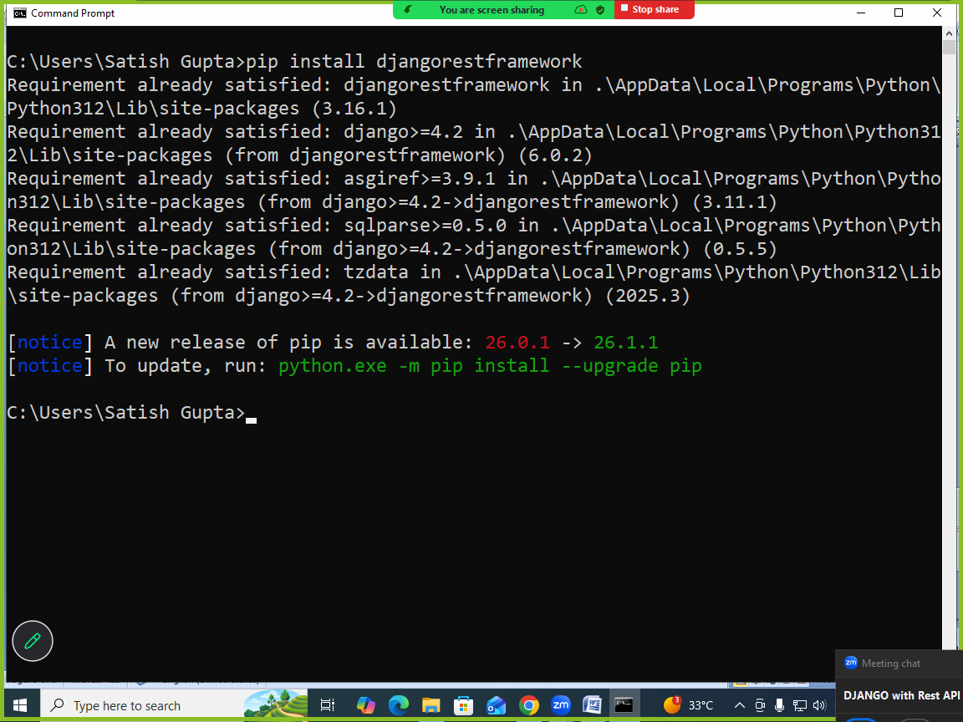

- Install rest_framework application by configuring in settings.py

INSTALLED_APPS=[….
‘rest_framework’,]

- Building API/REST API

Core Components
To build an API with DRF, you typically work with three main layers:
- Serializers: These act as the bridge between complex data (like Django model instances) and content types like JSON or XML. They also handle data validation for incoming requests.
- Views (or ViewSets): These handle the logic of the request. DRF offers APIView for fine-grained control and ViewSets to automatically handle common logic like "list," "create," "retrieve," and "update."
- Routers: When using ViewSets, routers automatically generate the URL configuration for your API, keeping your code clean and consistent.

PS C:\Users\Satish Gupta> cd D:\Backup\Django9amMar
PS D:\Backup\Django9amMar> django-admin startproject webapi1
PS D:\Backup\Django9amMar> cd webapi1
PS D:\Backup\Django9amMar\webapi1> python manage.py startapp api
PS D:\Backup\Django9amMar\webapi1>

Views.py
from django.shortcuts import render
from django.http import HttpResponse

# Create your views here.
import json
def listemployee(request):
employee=[{'empno':101,'ename':'naresh'},
{'empno':102,'ename':'suresh'},
{'empno':103,'ename':'kishore'}]
emplist=json.dumps(employee)
response=HttpResponse(emplist,content_type="application/json")
return response

urls.py
from django.contrib import admin
from django.urls import path
from api.views import listemployee
urlpatterns = [
path('admin/', admin.site.urls),
path('listemp/',listemployee),
]

Settings.py
INSTALLED_APPS = [
'django.contrib.admin',
'django.contrib.auth',
'django.contrib.contenttypes',
'django.contrib.sessions',
'django.contrib.messages',
'django.contrib.staticfiles',
'api',
]

